A. States of matter
- What are the three states of matter?

- Describe the movement and relative amounts of energy of particles in these three states of matter.

- What is used to represent particles in the simple particle model?

- What takes place at the melting point?

- What takes place at the boiling point?

- What factor affects the amount of energy needed to change state?

B. Pure substances
- What is a pure substance?

- How could you distinguish between a pure substance and a mixture?

- Why would scientists not call milk pure?

C. Separating techniques and chromatography
- What is the difference between a compound and a mixture?

- Describe the method used to collect the salt from a mixture of sand and salt.

- What process is used to purify seawater to obtain usable water?

- Describe how the following equipment is used to separate water and ethanol.

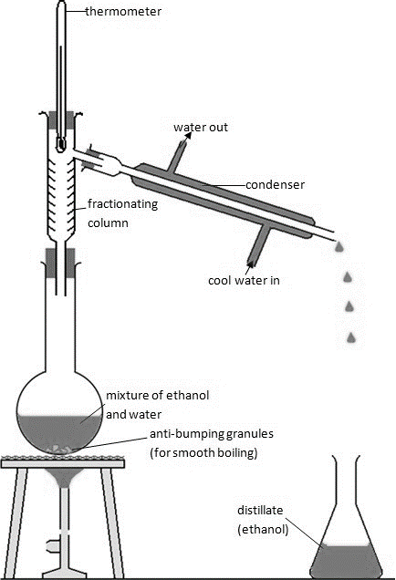

- A mixture and six colours are tested using chromatography. The following chromatogram was produced.
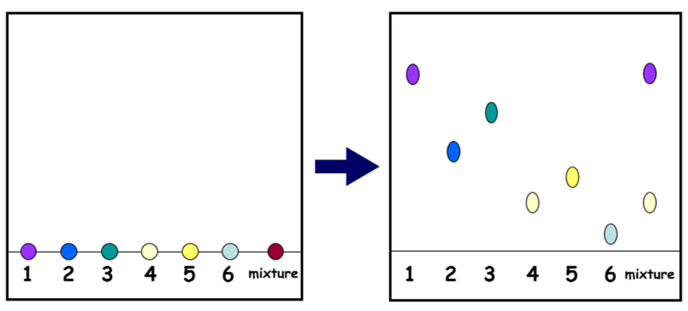

a) What can you conclude about the mixture?
b) Why do the inks separate?
- What is chromatograph?

- What happens in the stationary and mobile phases?

- A solvent travels 8cm up the stationary phase, two spots separate out. A travels 6cm up the mobile phase, B travels 4.5cm up the mobile phase. Give the Rf value for both to two decimal places.

D. Waste, ground water and sea water treatment
- Why is potable water not described as pure water by scientists?

- What does the method used to produce potable water depend upon?

- How is most potable water in the UK produced?

- What method can be used for the desalination of salty water?

- What needs to be removed from sewage and agricultural waste water?

- What are the three stages in the treatment of sewage?

